1.Create user with name Techie and provide sudo access touser.

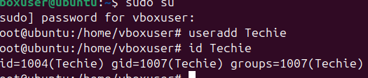

2.Navigate to the home directory.

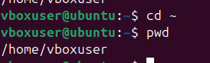

3.Create a new directory.



4.List the contents of a directory.

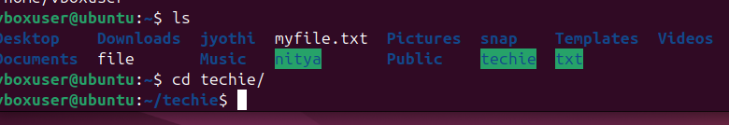

5.Change the current directory.

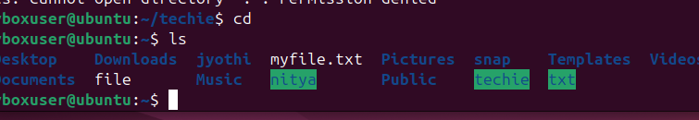

6.Create a new empty file.



7.View the contents of a file.

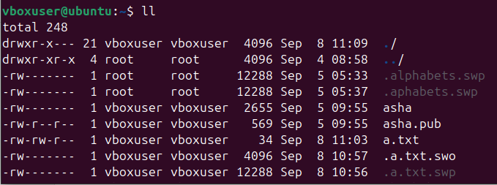

8.Copy a file to another location.



9.Move a file to another location.

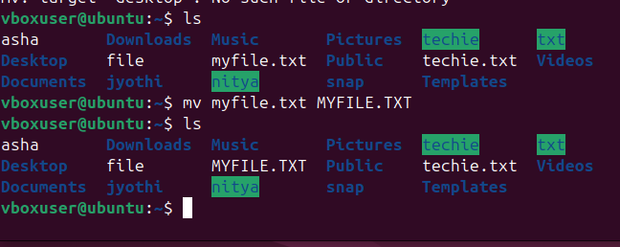

10.Rename a file.

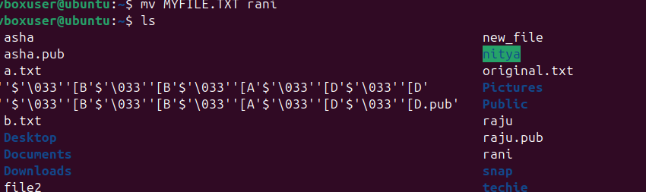

11.Delete a file

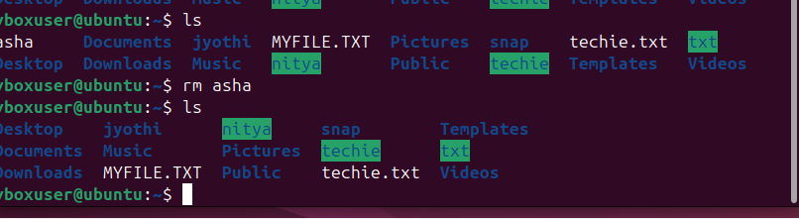

12.

Grant or revoke permission on a file or directory.



13.View the current date and time.

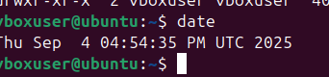

14.Check the system uptime.

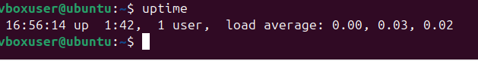

15. View the running processes.

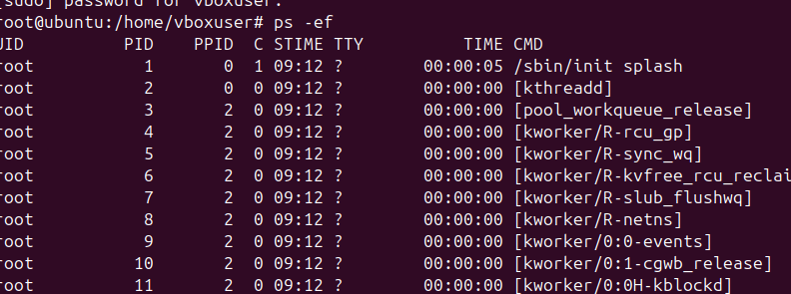

16.kill a running process.: kill -9 “pid”

17.Install a package using the package manager(e.g., apt or yum).

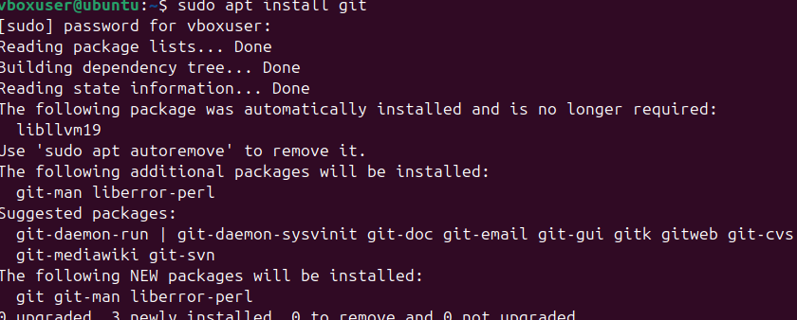

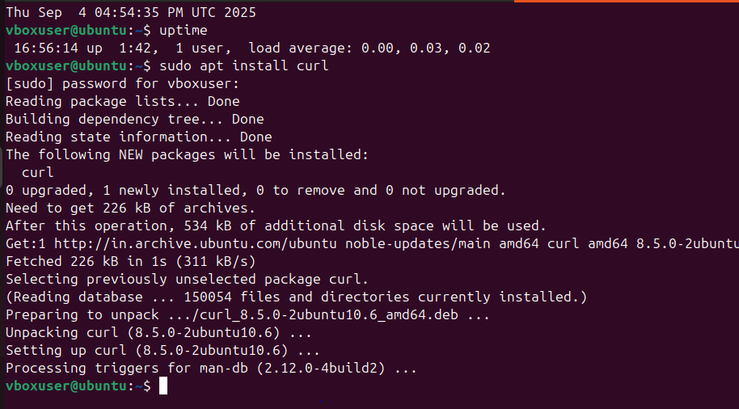

18.Update the system packages.

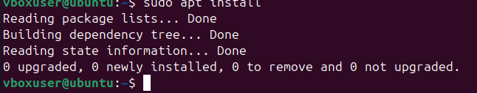

19.Create a symbolic link.

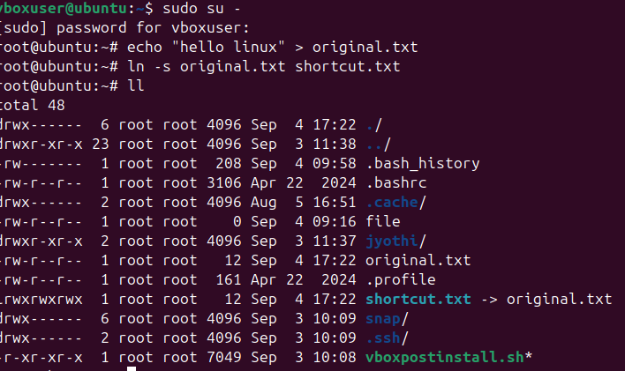

20.Search for files using the find command.

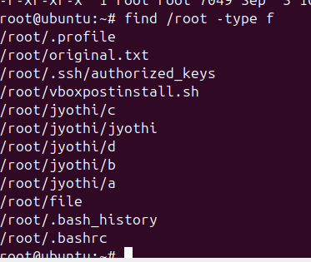

21.compress and decompress files using tar.

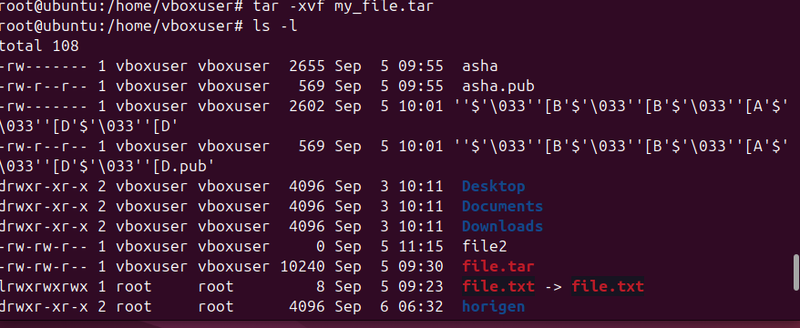

22.Monitor system resources with top or htop.

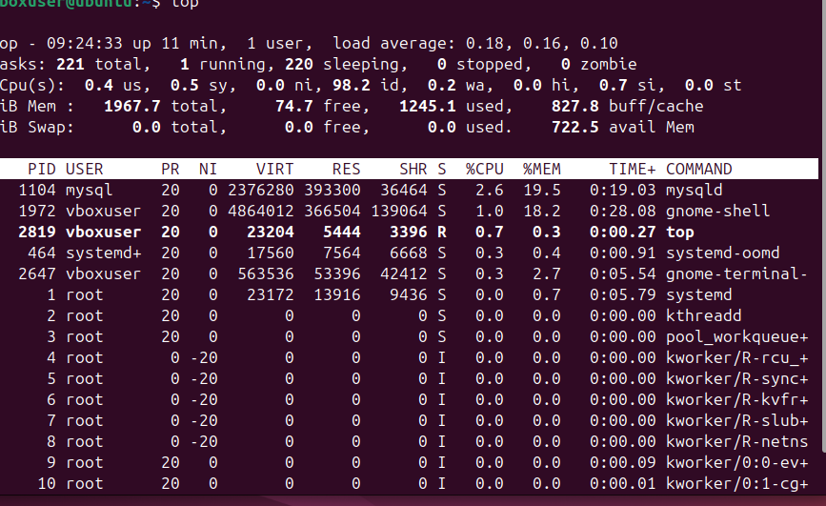

23.Create and manage user groups.

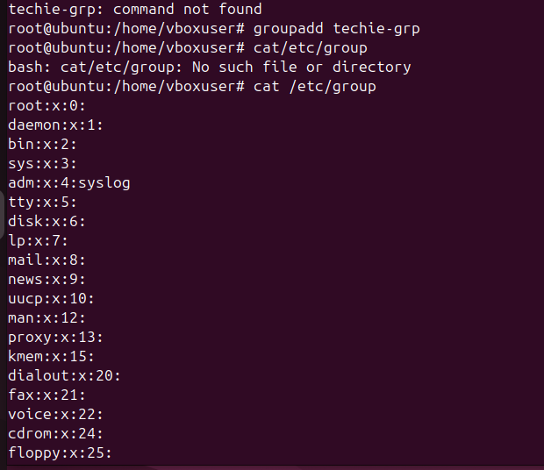

1. Setup SSH password less authentication.

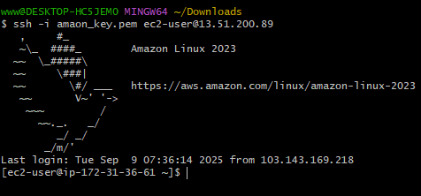

1. Monitor log files using tail or grep.

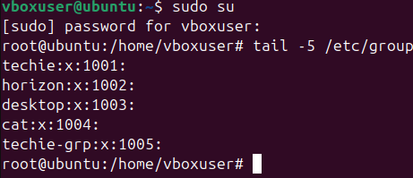

1. Set up a web server (e.g., Apache or Nginx )

Yum install httpd:

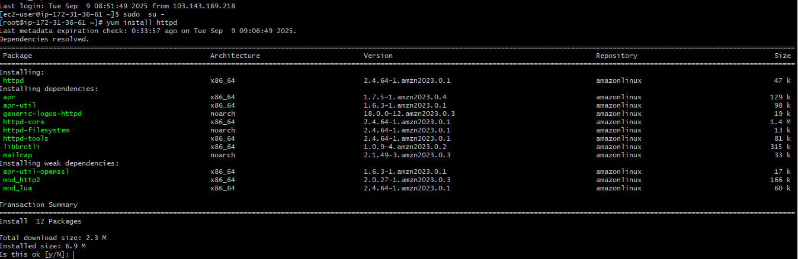systemctl status httpd:

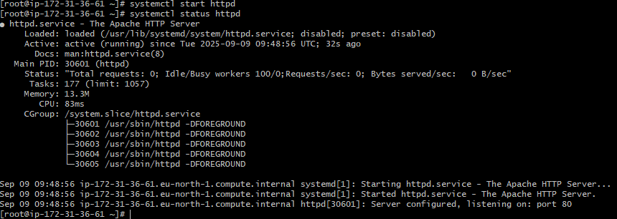

1. Configure and secure a My SQL Database.

28. Setup a Application Server (ex: Apache Tomcat)

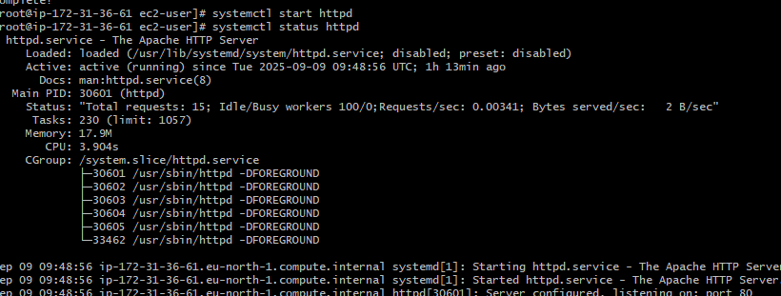.

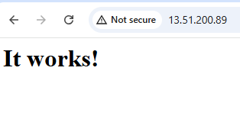

29 . Create a Service File for Apache Tomcat. ( should execute by systemctl command ).

30.Print specific columns from a delimited file.

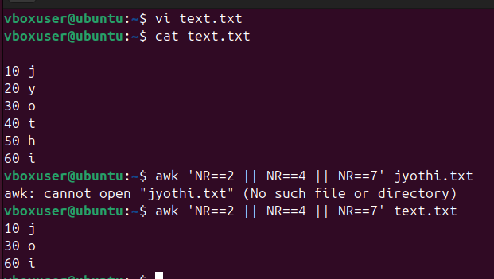

31.Filter and print lines based on a specific pattern or condition. 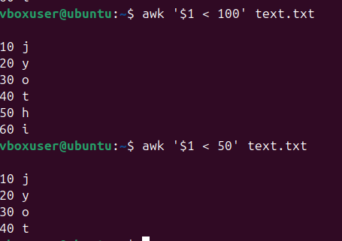

32.Calculate and print the average, sum ,or other statistics of a column.



33.Perform string manipulation, such as extracting substring or changing case.

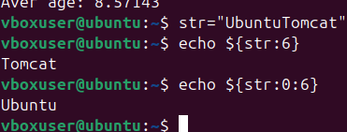

34.Count the occurrences of a specific pattern in a file.

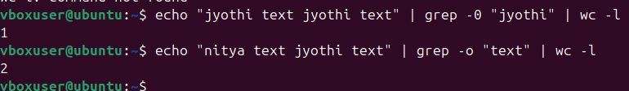

35.Sort lines based on a specific field or column.

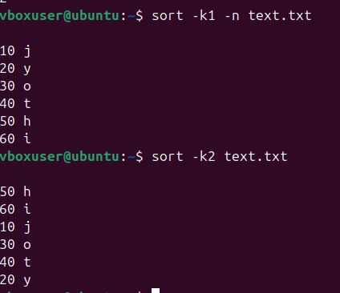

36.Merge multiple files based on a common filed or column.

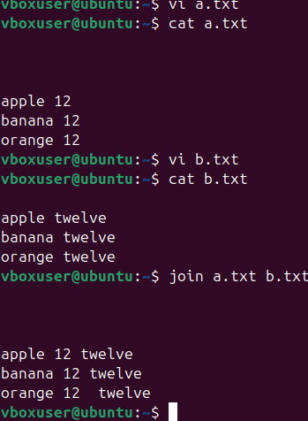

37.Substitute text in a file using search and replace.

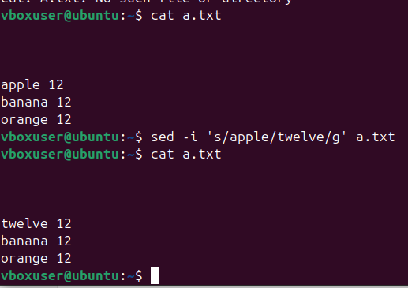

38.Delete specific lines based on a pattern or line number.

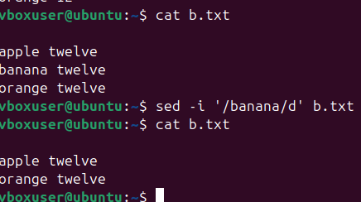

39.Append or insert text before or after a specific pattern or line.

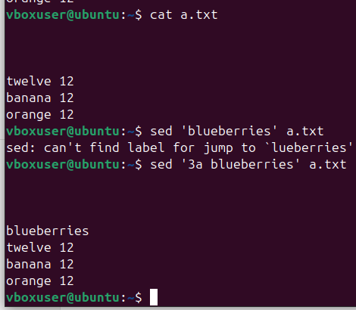

40.print only specific lines from a file.

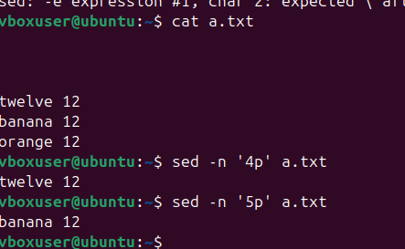

41.Copy file from linux to windows machine.

42.5 use cases for AWK and 5 use cases for sed.

